**The Five Themes of Geography**

**Day 2: Location**

**1. Location:**

Absolute Location: ______________________________________________________________

______________________________________________________________________________

Relative Location: _______________________________________________________________

______________________________________________________________________________

Latitude: ______________________________________________________________________

______________________________________________________________________________

Longitude: _____________________________________________________________________

______________________________________________________________________________

**2. Absolute Location:**

Writing Coordinates:

First write the degree of ___________________________

Example:

Second write the ___________________________

Example:

Third write the degree of ___________________________

Example:

Last: write the ___________________________

Example:

**3. Relative Location:**

Give an example of the relative location of your county

C:\Users\kmccarty\AppData\Local\Microsoft\Windows\Temporary Internet Files\Content.IE5\NV819WZT\MC900384054[1].wmf

**The Five Themes of Geography**

**Day 1: Place**

1. Define Geography: __________________________________________________________________

2. Write the five themes:

3. All places have characteristics that set them __________________ from other _________________.

4. Geographers describe places by both their ________________ and ______________ characteristics

5. Physical Features: _________________________, ecosystems, _______________________, animal life, other __________________________ features

6. Human Characteristics: __________________________________, ______________________, customs, ________________________, government, architecture, religion, and so on…

7. *Check for Understanding*:

What are the physical and human characteristics of our middle school?

How is our school different from other schools?

**8. ABC Book Activity:** You will create part of an ABC book to describe your hometown. You can describe the unique physical features, the buildings, the weather, traditions, people, or so on. When you are finished the book should tell people unfamiliar with your community what it is like to live there.

1. Choose a topic for each letter

Example: B is for Blue and Gold

1. Create a four line rhyme the describes your word (the last word of the second and fourth line should rhyme)
2. Write a paragraph describing more about your topic – the paragraph needs to be at least five sentences
3. 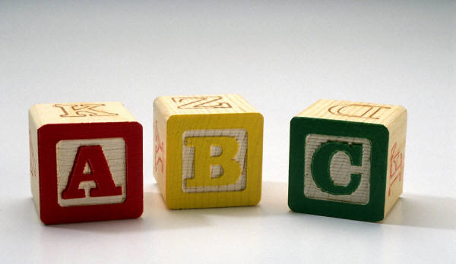Draw and color a picture for your letter

**The Five Themes of Geography**

**Day 3: Region**

1. Define Region: ___________________________________________________________________

____________________________________________________________________________________

These similar characteristics may be _____________________, human, or _____________________.

2. How do regions help geographers?

1. They help _____________________ the ____________________ to make it easier to study

2. Regions help us to learn about the _____________________ and _____________________ that help our _____________________ function as a unit

3. Types of Regions

* Region - a group of places with at least one common __________________________ or human _______________________, and may be determined by people’s ________________________, influenced by one’s ____________________________ and experiences.
* You can think of regions as having both *human* (_________________________) and *physical* (_____________________________) characteristics

Formal Region: ______________________________________________________________________

____________________________________________________________________________________

Examples: _________________________________________________

Functional Region: ___________________________________________________________________

____________________________________________________________________________________

Examples: _________________________________________________

Perceptual Region: ___________________________________________________________________

____________________________________________________________________________________

Examples: _________________________________________________

**The Five Themes of Geography**

**Day 4: Movement**

1. During a common day what different objects or people do you interact with?

2. What are some of the different ways you communicate with other people?

3. Question to ask to understand Movement:

* + ______________________ …
  + What…
  + _______________________ …
  + _______________________…
  + … and why do things, people and information move?
  + _______________________ do things move?

4. How do ideas travel from place to place?

In ancient times?

* + Today?

5. The theme of _________________________ helps us understand how we are _________________________ with, and _________________________________ upon, other ____________________________, cultures, and _____________________________ in the __________________________________.

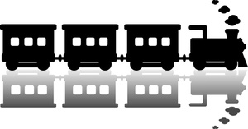

**The Five Themes of Geography**

**Day 5: Human Environment Interaction**

1. How do you affect your environment everyday?

2. As the seasons change does your impact on the environment change?

3. How does the environment affect people?

4. Depending on your _________________________ background and _________________________ resources the _________________________ means different things to different people.

5. When we study _________________________ -Environment _________________________ we look at all the effects (both _________________________ and negative) that occur when people interact with their _________________________.

7. How can we modify our environment?

8. How do we adapt to it our environment?

9. How can changes to the environment be favorable?

10. How can they be destructive?